Name _________________________________ Fingerprint Notes

Period ________ Date ___________________ Forensics

1. What are fingerprints?
   1. A fingerprint is an impression left on any surface that consists of patterns made by the ridges on a finger.
   2. The imprint of a fingerprint consists of natural secretions of the sweat glands (water, oil and salts) and dirt from everyday activity.
2. Fingerprint Skin
   1. Our fingers are covered with hundreds of microscopic sweat pores.
      1. They make our fingers moist and able to grip better.

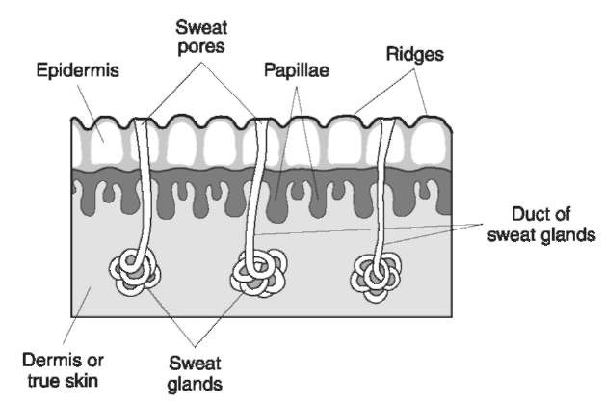

1. Fingerprint History
   1. Several thousands of years ago ancient civilizations used fingerprints as markings.
      1. 1792 – 1750 BC clay tables had fingerprint seals
      2. Ancient china used inked fingerprints on official documents
   2. In the Western Culture
      1. 1684 – Dr. Nehemiah saw and described fingerprints
      2. 1788 – Johann Christoph Andreas Mayer described
         1. “the arrangement of skin ridges is never duplicated in two persons”
      3. 1879 Alphonse Bertillion, created a new way to identify criminals
      4. 1896 Sir Edmund Richard Henry created a system of fingerprint classification based on whorls, arches and loops

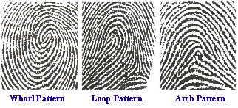

1. Formation of Fingerprints
   1. Fingerprints are probably formed at the beginning of the tenth week of pregnancy. (When the fetus is 3 inches long)
   2. The creation of fingerprints happens in the basal layer
      1. The basal layer is part of the epidermis where new cells are created.
   3. The basal layer grows faster than the other skin layers. It collapses and folds in different directions due to a lack of space.
   4. The pattern of fingerprints cannot be altered destroyed permanently by minor skin injuries – because the epidermis protects it
      1. There are some genetic abnormalities which cause people to be born without fingerprints.
      2. Drugs for chemotherapy can cause fingers to swell and skin to come off. Fingerprints will grow back though.
      3. Bricklayers wear off their fingerprints but they will grow back after a while.
      4. Deep burns and scars produce unique identifying marks.
   5. Similar prints are formed at the same time: palms of hands, soles of feet and the lips.
   6. Identical twins do not have identical fingerprints.
   7. 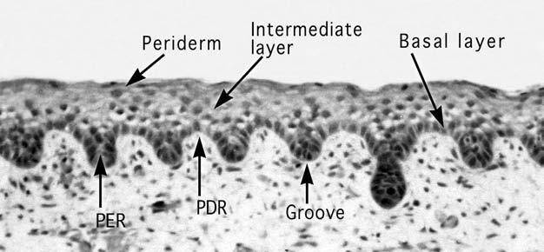

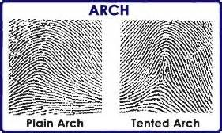

1. There are Basic Types of Fingerprints
   1. Arches – 5% of population
   2. Whorls – 30% of population
   3. 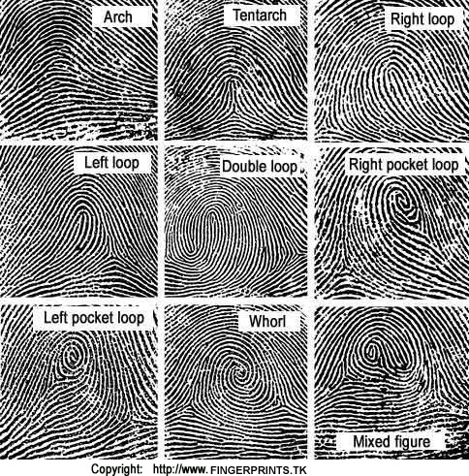Loops – 65% of population

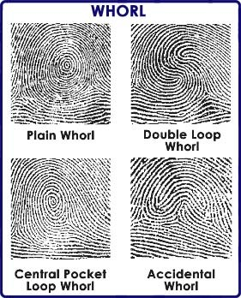

1. Fingerprint Minutiae are the points on interest in fingerprint identification

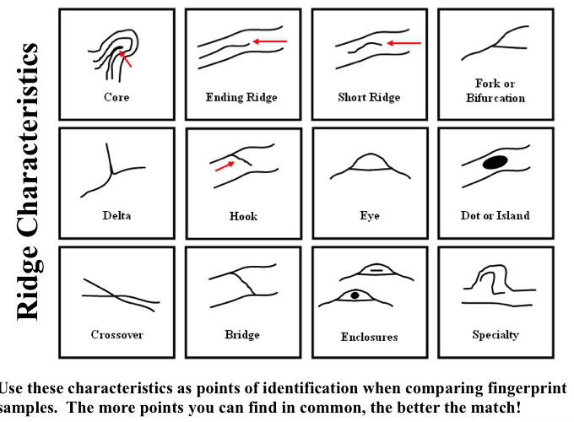

1. Fingerprint ridge counting is another way that we can identify fingerprints.
   1. Investigators count the number of ridges between the core and a delta in a fingerprint.

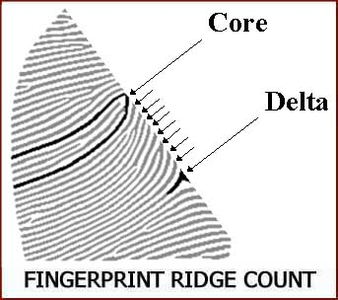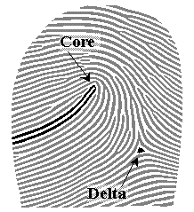

1. Types of fingerprint identification
   1. Patent fingerprints (visible prints)
      1. Prints are left on a smooth surface when blood, ink or other liquid comes into contact with fingers and is transferred to that surface
   2. Plastic fingerprints are actual indentations left in soft surfaces (ex. Wax, clay)
   3. Latent fingerprints are hidden prints.
      * 1. They are left by the transfer of oils onto a surface
        2. Made visible by dusting with powders.
2. Fingerprint Facts
   1. Can fingerprints be altered?
      1. Not under ordinary circumstances, they will grow back
      2. If fingerprints are altered, they will bill just as identifiable.
   2. How reliable is fingerprinting?
      1. Humans can make mistakes
      2. Out of 185 examiners studied, 1 in 5 people made a false positive.
   3. How are fingerprints Analyzed?
      1. Until 1999 fingerprints were searched manually (3 months).
      2. AFIS (Automated Fingerprint Identification System) is used by law enforcement (2 hours)
         1. Criminal master file is the largest database
         2. Contains fingerprints and history of 47 million people
3. Latent Fingerprint collection
   1. Dusting with fine carbon powder that can “bring out” fingerprints.
   2. Tape is then used to lift and preserve the prints.
   3. Magnetic powders can also be used.
   4. To recover a print from a surface that is not hard and smooth requires the use of different chemicals.
   5. When fingerprint residue combines with chemicals the print becomes visible.

|  |  |  |  |  |  |
| --- | --- | --- | --- | --- | --- |
| Chemical | Uses | Application | Safety | Chemical Reaction | Latent Print |
| Ninhydrin | Paper | Object dipped or sprayed | Do not inhale or get on your skin | Reacts with amino acids found in sweat | Purple – blue print |
| Cyanocrylate vapor | Household items, plastic, metal, glass and skin | Heat sample in a vapor tent | Do not inhale or get on skin, irritant to mucus membranes | Reacts with amino acids | White print |
| Silver Nitrate | Wood, Styrofoam | Object diffed or sprayed | Wear gloves, avoid contact to skin | Chloride from salt in perspiration on the print combines with silver nitrate to form silver chloride | Black or reddish brown print under UV light |
| Idoine Fuming | Paper, cardboard, unpainted surfaces | In a vapor tent, heat solid iodine crystals | Toxic to inhale or ingest | Iodine combines with carbohydrates in print | Brownish print fades quickly, must be photographed, or sprayed with a solution of starch. |